What is a Positive Role Model?
A positive role model doesn’t need to have any special skills—you don’t need to be a sports hero or a billionaire for youth to look up to you. In fact, most youth who said that they had role models identified them as caring friends and relatives.

Every single one of us has to potential to make a difference in the lives of young people—all that matters is being willing to take the time to get to know a young person and let them get to know you, and to share your experience and knowledge.

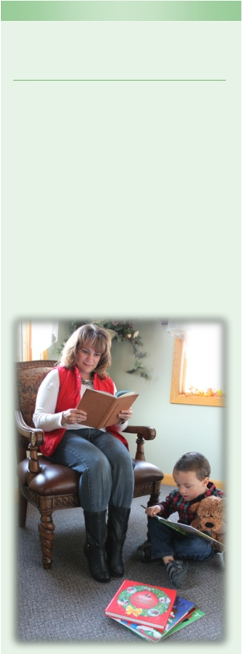

“Seeing is Believing”

I spoke to a lady who shared that her husband no longer uses smokeless tobacco because of their little girl. When their daughter was four, she began spitting. Her daddy asked her to stop doing that, and she replied, "but you do it, daddy." It occurred to him that he did spit as he used smokeless tobacco. He stopped using. Sandy Miller
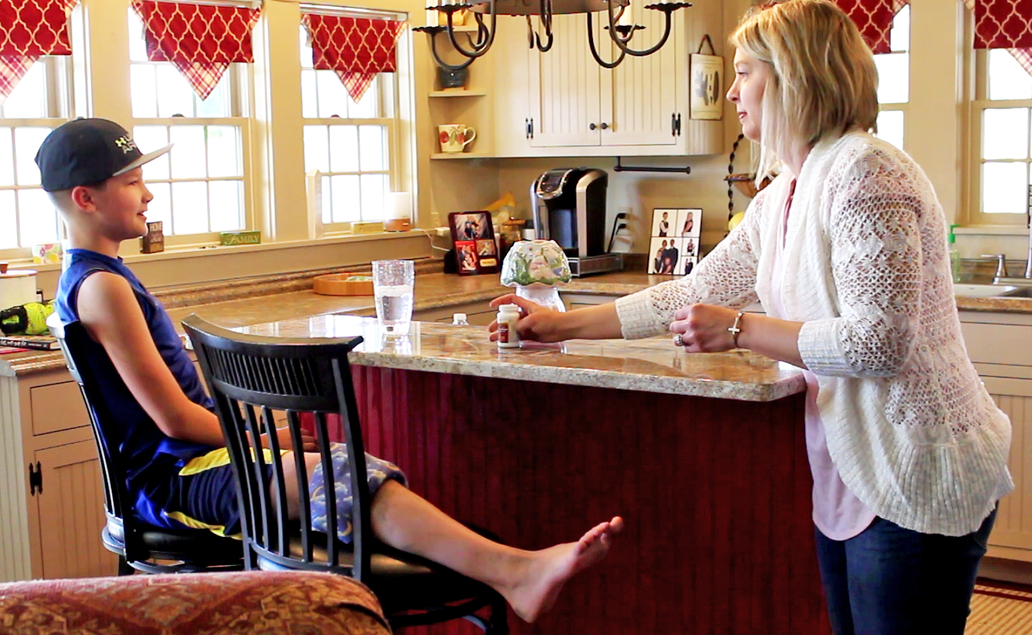

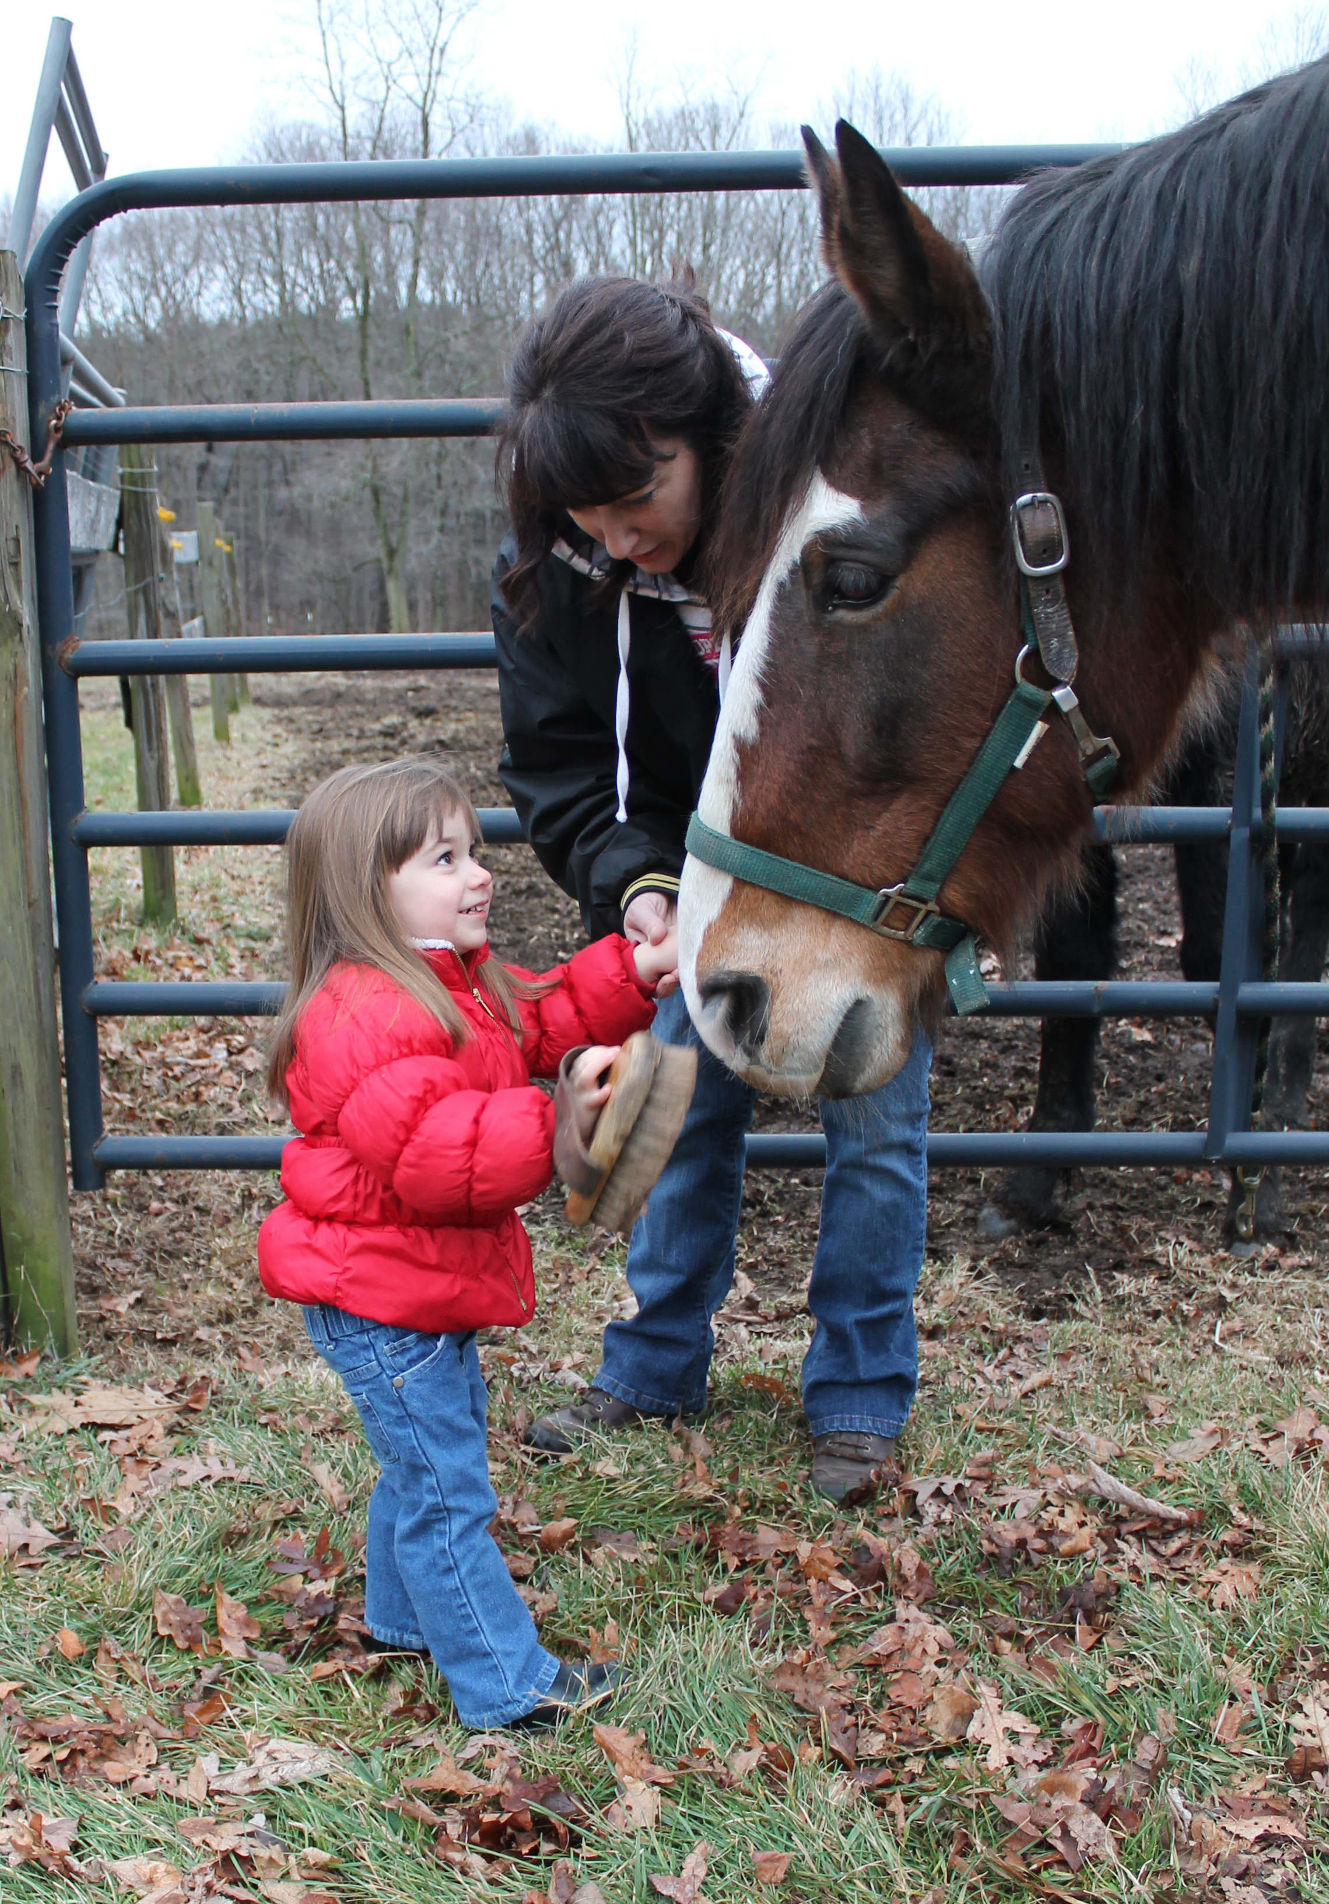

“Show your kids the way to deal with sports injuries by using safer alternatives than opioids.”

A Campaign About the

Garrett County Health Department
1025 Memorial Drive
Oakland, Maryland 21550
Phone: 301-334-7730 or 301-895-8111
Fax: 301-334-7731

Funded through GCHD with funds from MDH and SAMHSA

Importance of Adults as

Positive Role Models

• Role models play a major part

in how our children turn out.

- Adults model responsible behavior
Search Institute’s Developmental Asset #14

Visit search-institute.org for more information on the 40 Developmental Assets All Kids Need to Succeed.

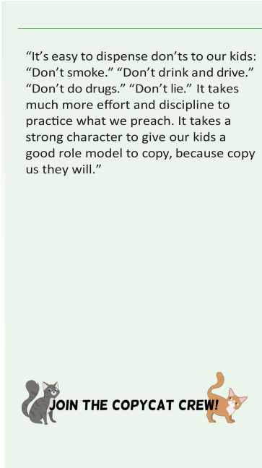
Ways to be a positive Role Model

Garrett County Health Department

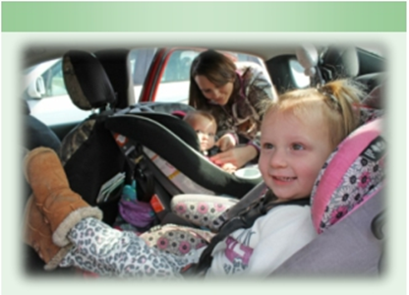

The Importance of Role Models

When we reflect back on the experiences that shaped us when we were young, we often remember a special adult in our lives. It might have been a parent, grandparent, sibling, aunt, uncle, teacher, coach,
older relative, community member, or other caring adult that made a big impact on us. We see these role models as being important in shaping our lives. And that’s no surprise— research shows that positive adult role models have a tremendous impact on children, young people and can have the following benefits:
    - Higher levels of self esteem
    - Reduced use of tobacco, alcohol,
marijuana, and other drugs
- Improved high school graduation
rates
Keep this in mind: Teaching by example is often
Easier and more effective than forcing children to
Obey rules by scaring, threatening, or tempting
Them with rewards.
- Greater aspirations and
expectations for their careers
- Hope for the future, dreams and
visions.

Karen Stephens
-Child Development Educator & Author

Children receive mixed messages in regards to tobacco, alcohol and other drug use. They are ‘copy cats’ in every way. The ’Just Like You!’ campaign is created to show adults, the impact they have on children. Positive role modeling will be displayed through a variety of media and marketing venues.

'Just Like You!’ online

Check out Copycatfun.com for information about healthy behaviors, alcohol, tobacco and other drug prevention. Also, totally cool, interactive activities for you and your child.

Revised: 1/14/2020
Challenge yourself to identify the positive things that you can role model for your kids, things
like:

• Happiness
• Consideration
• Self-respect
• Patience
• Generosity
• Self-discipline
• Diligence
• Kindness
• Bravery
• Compassion
• Feeding your body with wholesome and
nourishing food
• Expanding your mind with enlightening
reading
• Exercising for physical and mental health,
speaking well about yourself and others, and enjoying life with friends and family
• Inspire kids to big dreams and
achievements
• Develop values
• Promote selflessness and a commitment to
others
• Highlight one's ability to overcome
obstacles
• Teach children to respect differences
• Reinforce your own values
• Minimize antisocial behavior
• Help kids with specific struggles or
difficulties
• Develop positive attitudes
• Encourage children to set & achieve goals
• Instill the concepts of hard work and
perseverance

Adapted from: https://goo.gl/h0DGRY

